**For Mac, few points need to keep in mind.**

1. Unlike Windows machine, here Command key is used instead of Control

Command +S: Save

Command +C: Copy

Command +V: Paste

Command +Tab: Moving from one window to another

1. In windows we use cmd to run the commands , in max we have terminal (can be search using Finder)

**Step 1. Open Terminal and run below Command to install Homebrew (Homebrew is package manager for MacOS and through it you can install, uninstall, update software in mac)**

**Run this:**

/bin/bash -c "$(curl -fsSL <https://raw.githubusercontent.com/Homebrew/install/HEAD/install.sh>)"

Note: (Above is complete command to install homebrew)

🡪 If it is asking for password, then enter your System Password (Password to login into system)

🡪 Press Enter/Return to continue for installation

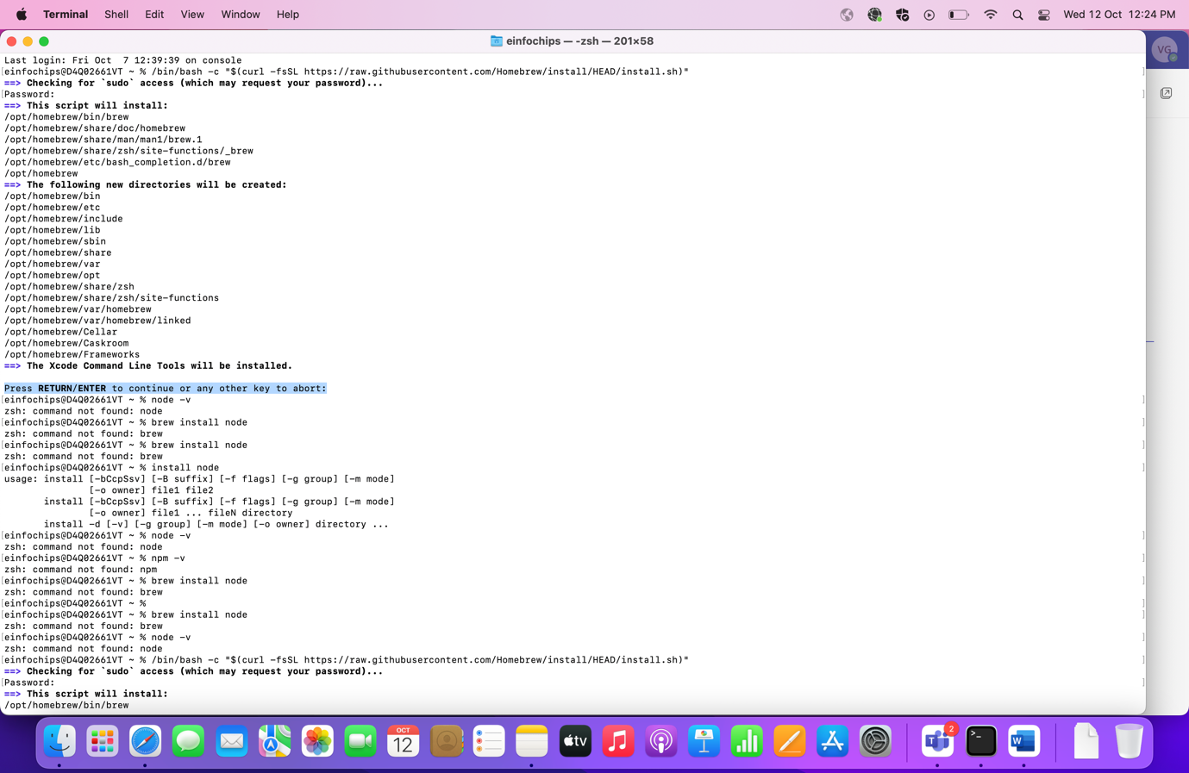

🡪 It willsStart downloading and at last the message will be displayed that Installation is completed successfully with instruction to run below three commands

Run these three commands in your terminal to add Homebrew to your **PATH**:

**Run these:**

1. echo '# Set PATH, MANPATH, etc., for Homebrew.' >> /Users/einfochips/.zprofile

2. echo 'eval "$(/opt/homebrew/bin/brew shellenv)"' >> /Users/einfochips/.zprofile

3. eval "$(/opt/homebrew/bin/brew shellenv)"

**Step 2. Run below command in terminal to install node (Node js/npm is required for Appium Server)**

**🡪Run this:**

brew install node

🡪Once installation is completed run the below commands to check the node version

**🡪Run these:**

node -v

npm -v

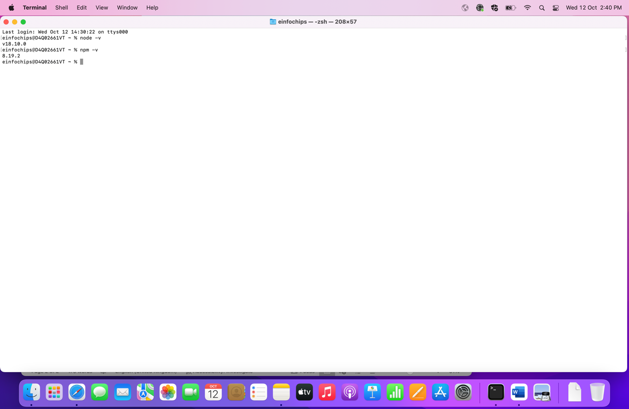

**Step: 3. Install Appium server using npm command (We can start the server by GUI or through command and here we will work on both in step 3 and 4)**

**🡪Run this:**

npm install -g appium

🡪Once installation is completed, run the below command to check the version and to verify that server is started or not.

**🡪Run this:** (to check version of Appium)

appium -v

**🡪Run this:** (to start appium server)

appium

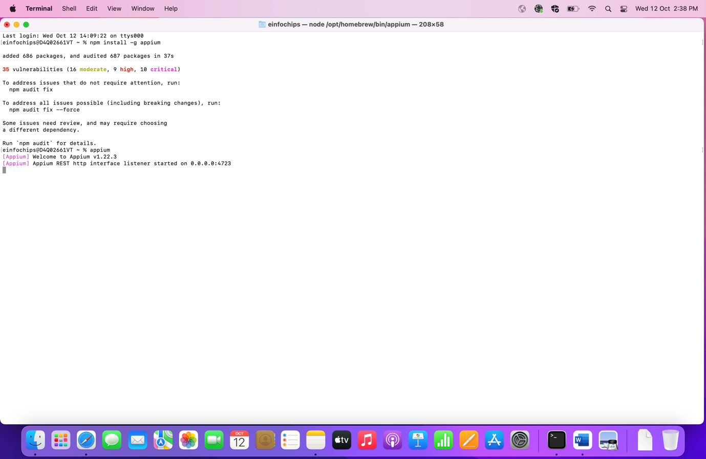

**Step 4. Download and install appium server using Appium Desktop Client**

🡪Go to below URL and you will find the different version of Appium Desktop Client for different OS.

<https://github.com/appium/appium-desktop/releases/tag/v1.22.3-4>

🡪Download the version for macOS as shown in below screenshot

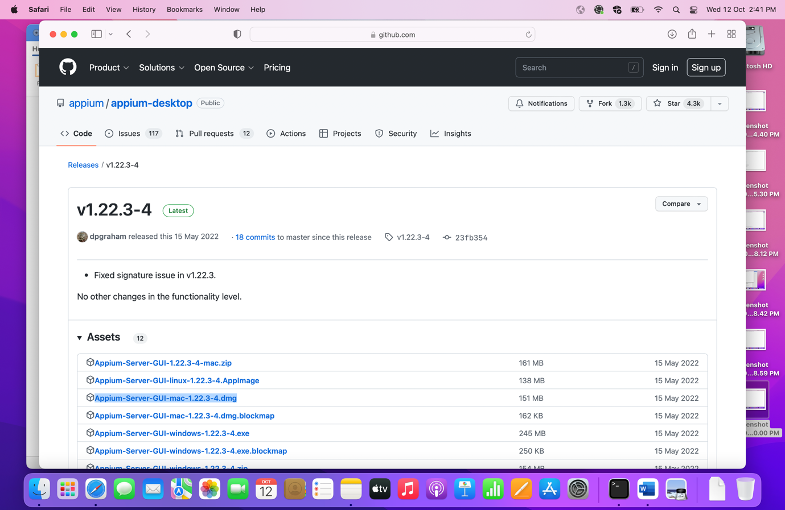

🡪Once it is downloaded, a pop up will be displayed where You can move your Appium Server GUI to Application.

🡪Drag it to the Application and then verify Appium Server GUI is available in Application folder now.

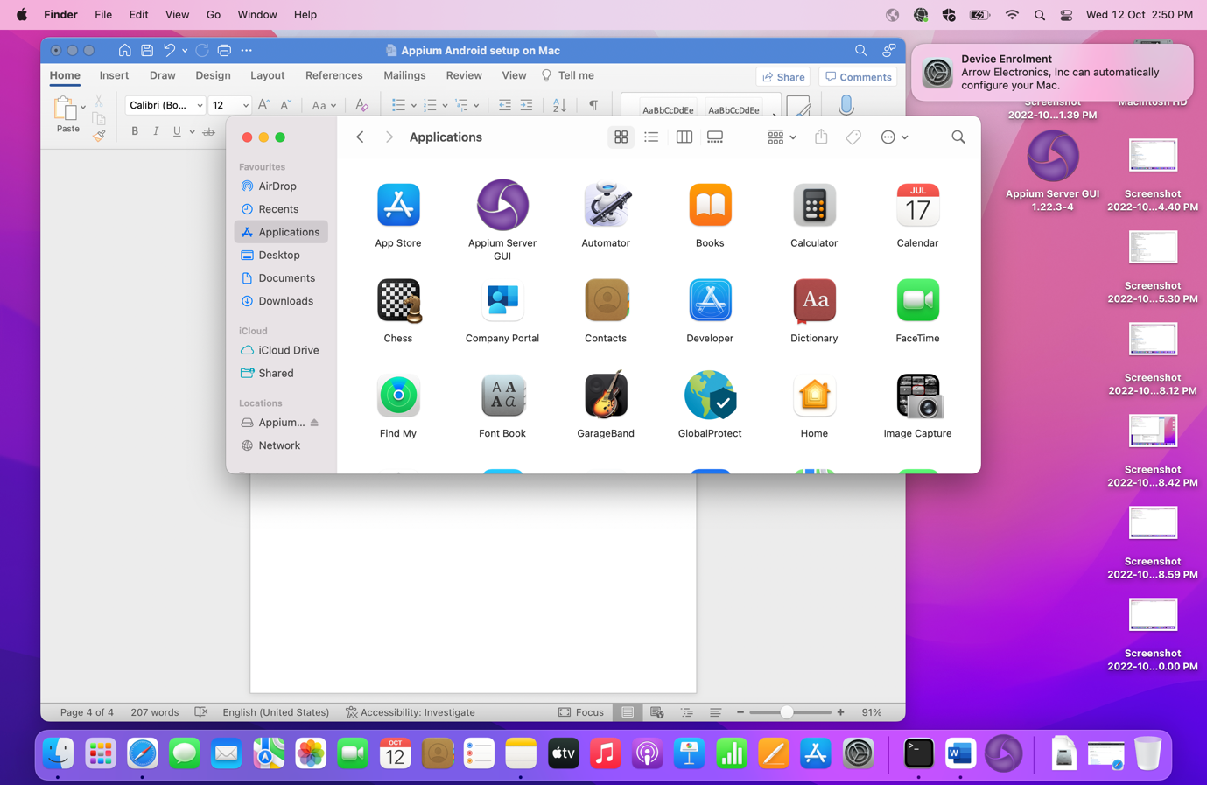

🡪Now open the Appium Server and click on Start Server and verify that server is launching properly or not.

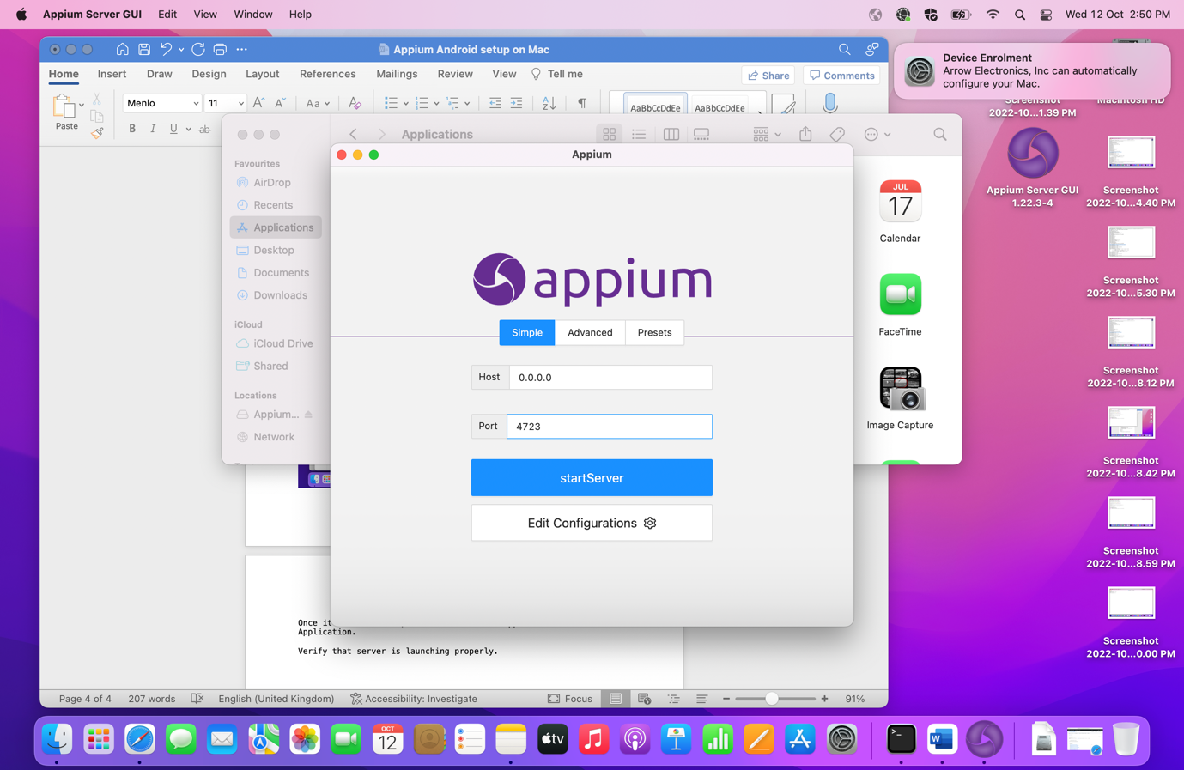

**Step 5. Download and install Appium Inspector (Appium Inspector is used to locate the mobile elements. We can find the elements by id, xpath, class etc..)**

🡪Go to below URL and you will find different Appium Inspector

<https://github.com/appium/appium-desktop/releases/tag/v1.22.3-4>

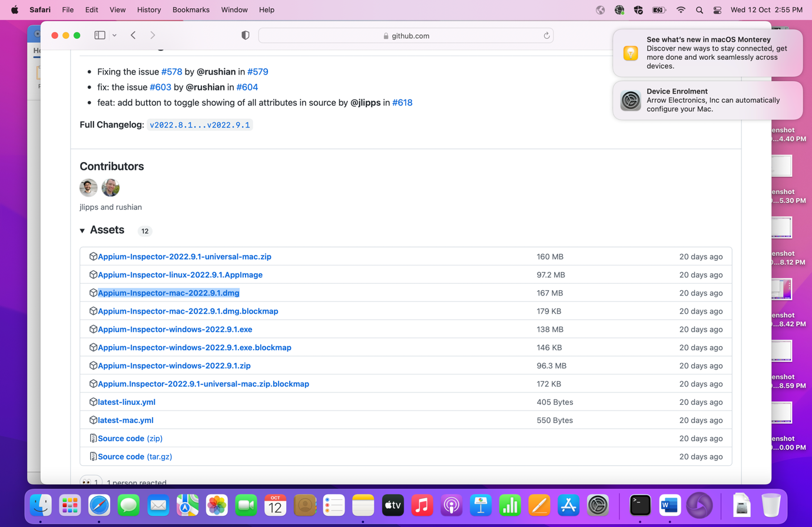

🡪Once it is downloaded, a pop up will be displayed where you can move your Appium Inspector to Application.

🡪Drag it to the Application and then verify Appium Inspector is available in Application folder now

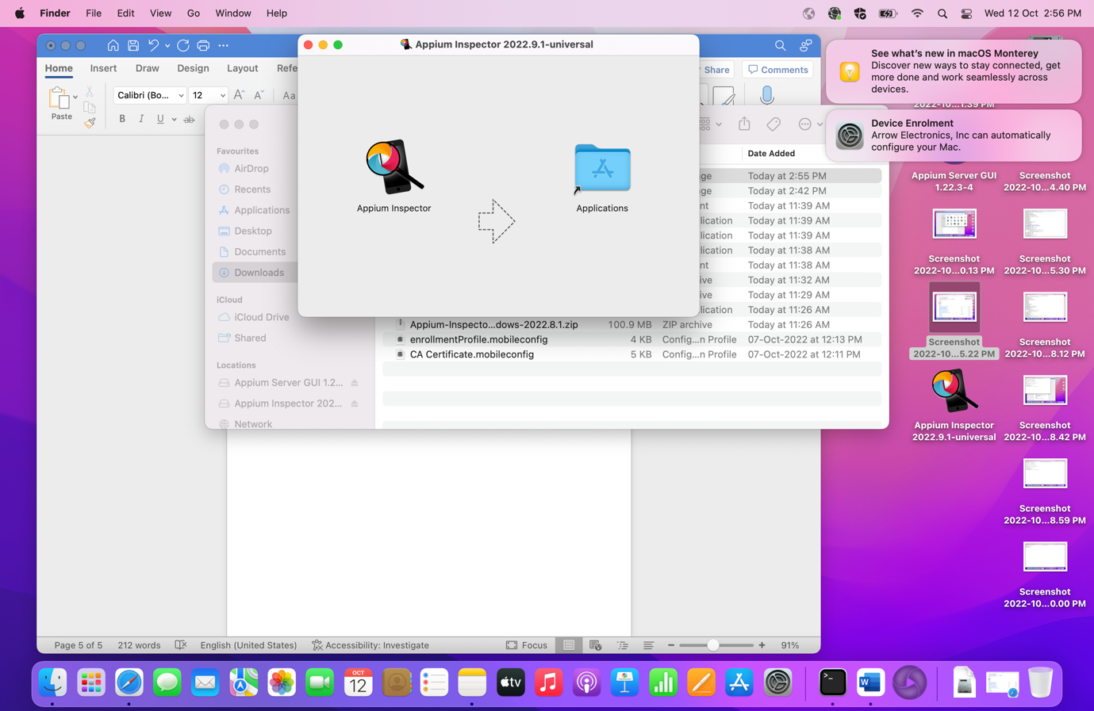

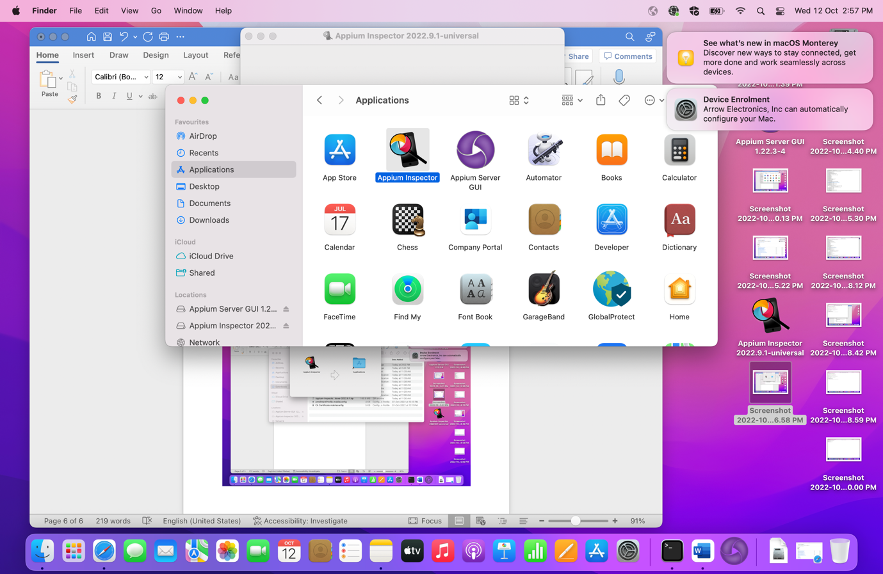

🡪Launch Appium Inspector

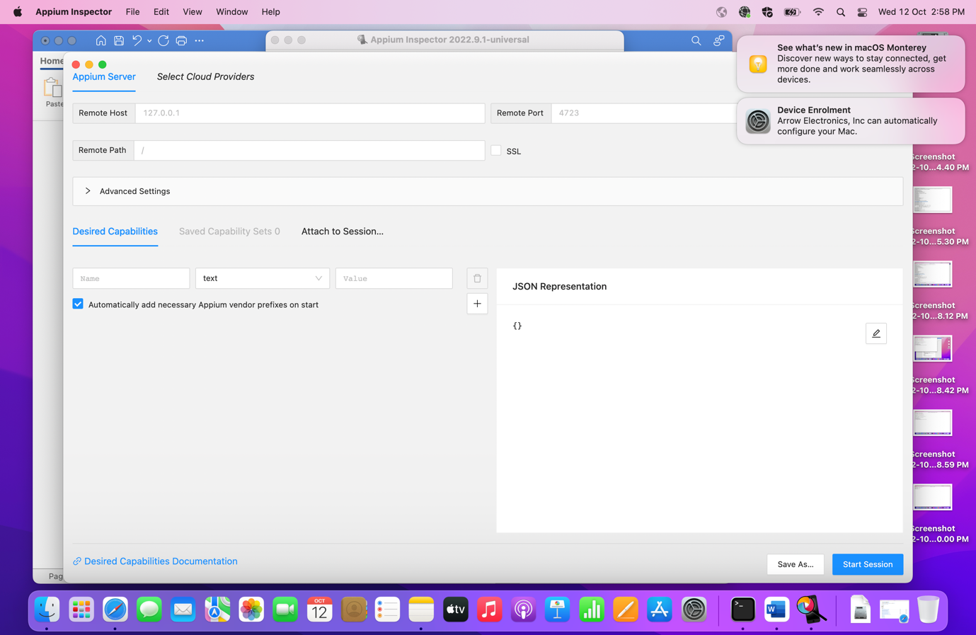

**Step 6. Install Java JDK**

🡪Download JDK from given below link

<https://www.oracle.com/java/technologies/javase/jdk18-archive-downloads.html>

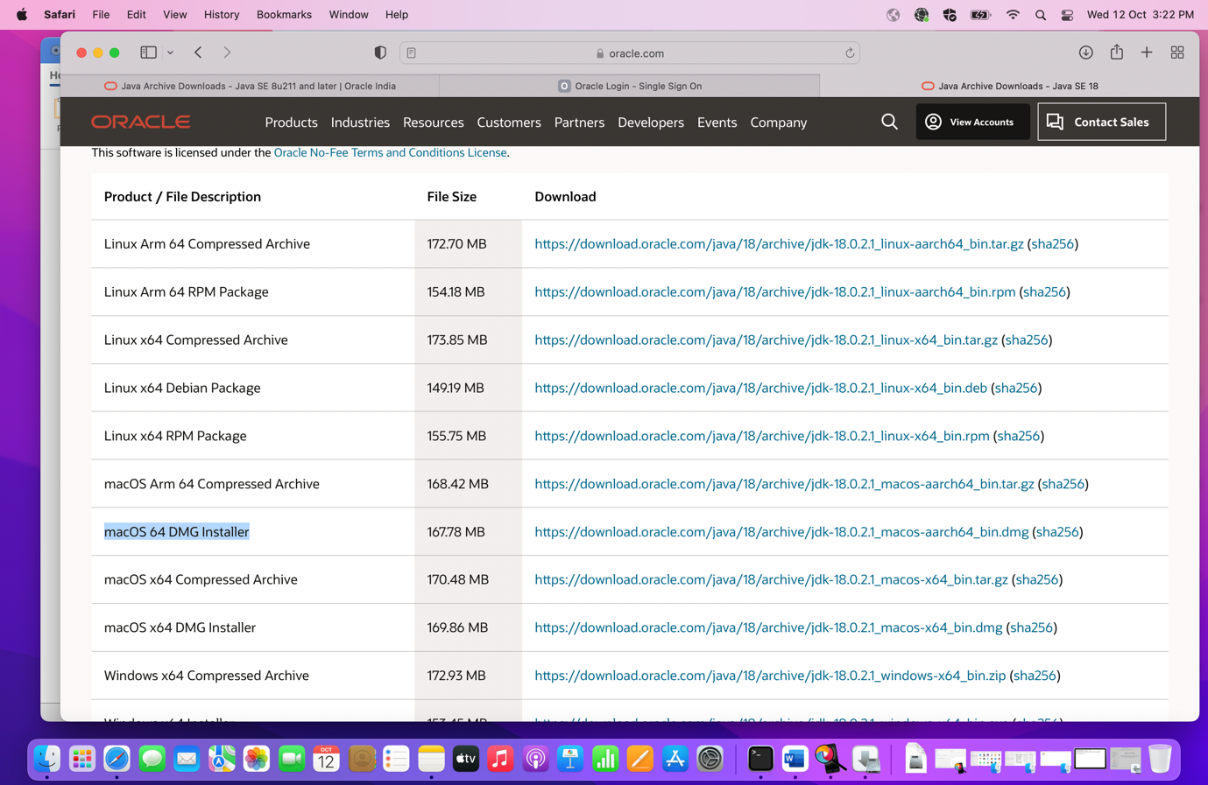

🡪Once it is downloaded, install the JDK.

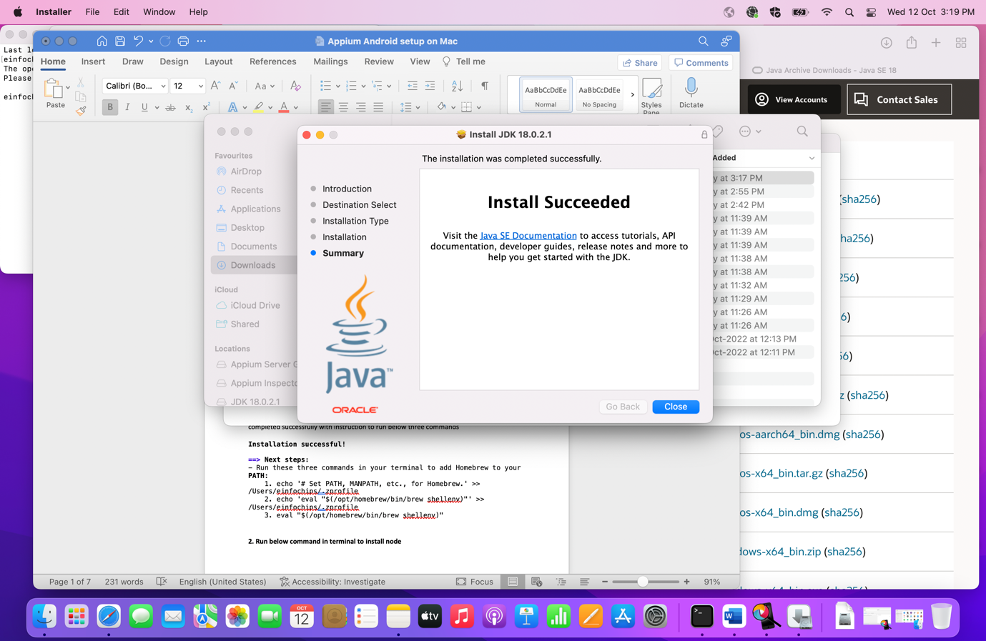

🡪Pop up is displayed for moving installer to Trash or bin folder. Move it to to Bin.

🡪Run the below command in terminal and check the version of Java

**🡪Run this:**

Java -version

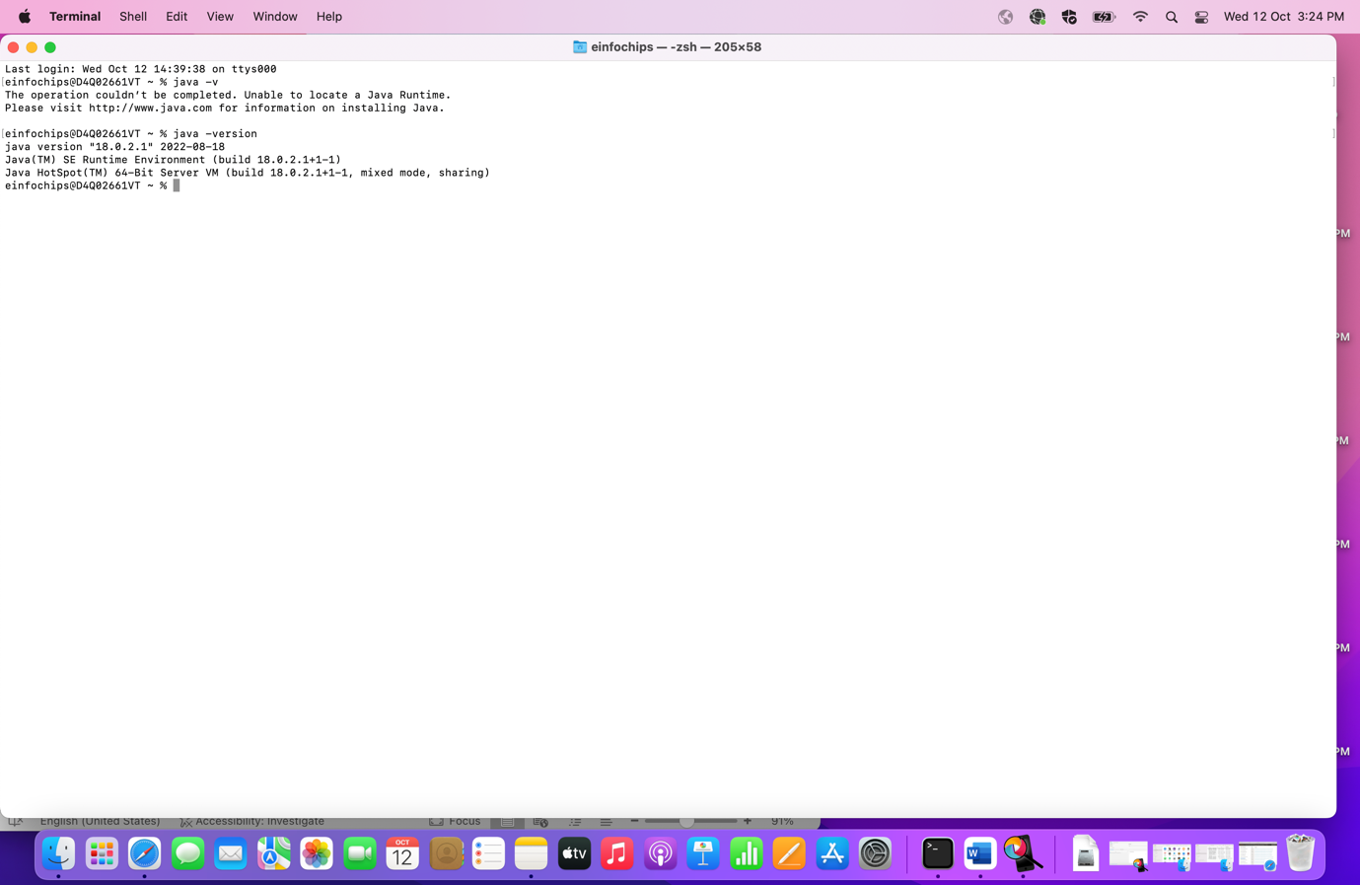

**Step 7.Install Android Studio (Android Studio is**the official Integrated Development Environment (IDE) for Android app development**)**

🡪Download studio from the below link

<https://developer.android.com/studio>

🡪Click on Download Android Studio

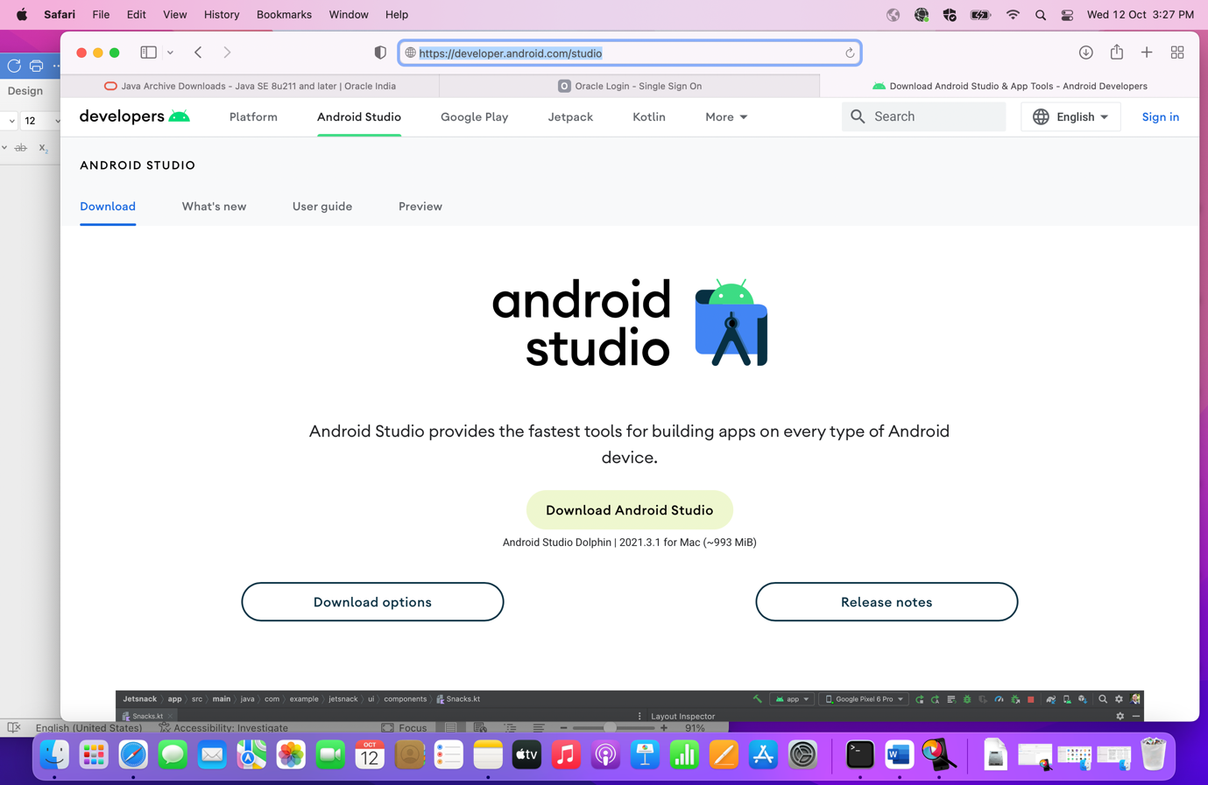

🡪Scroll down the Terms and Conditions page

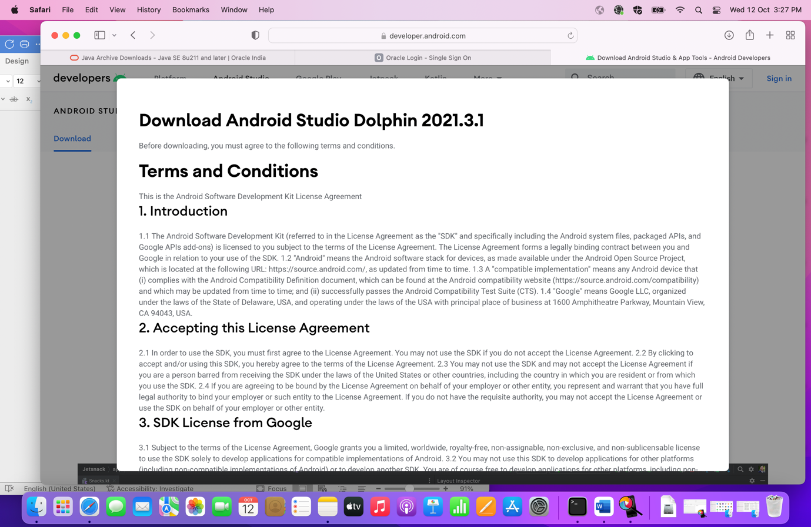

🡪Select the Condition checkbox and find your chip by following below steps

* To know about chip, Click on apple icon -> About this mac

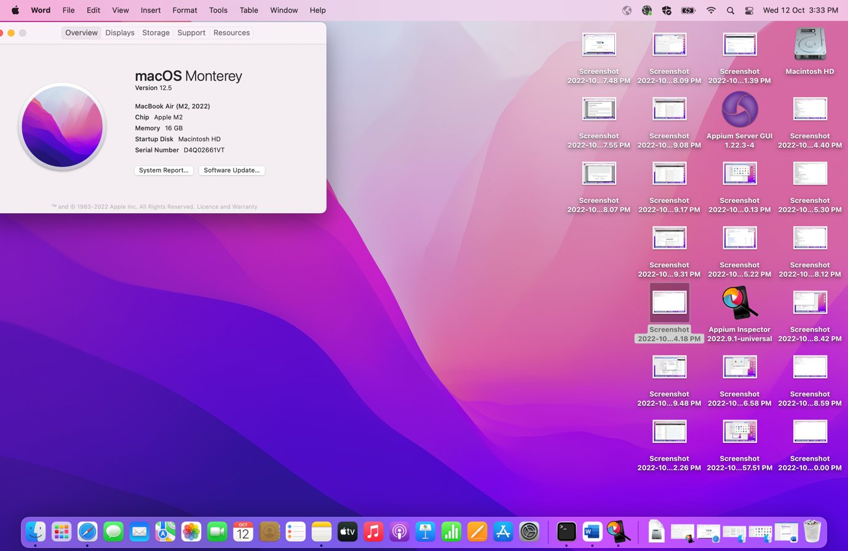

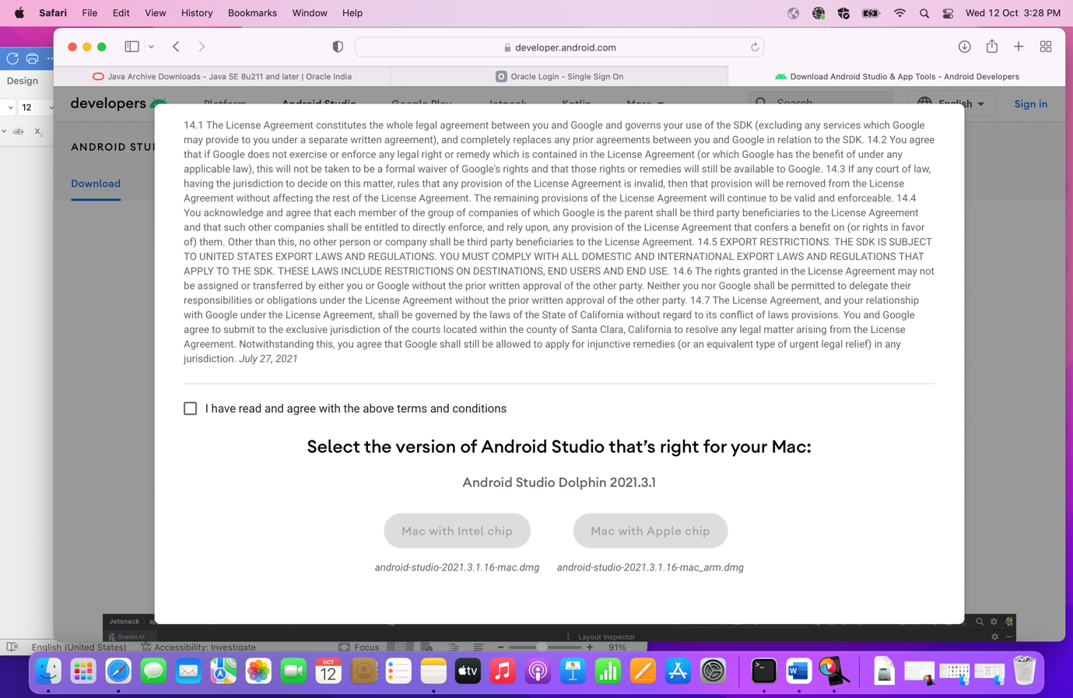

🡪Once studio is downloaded, move it to Application

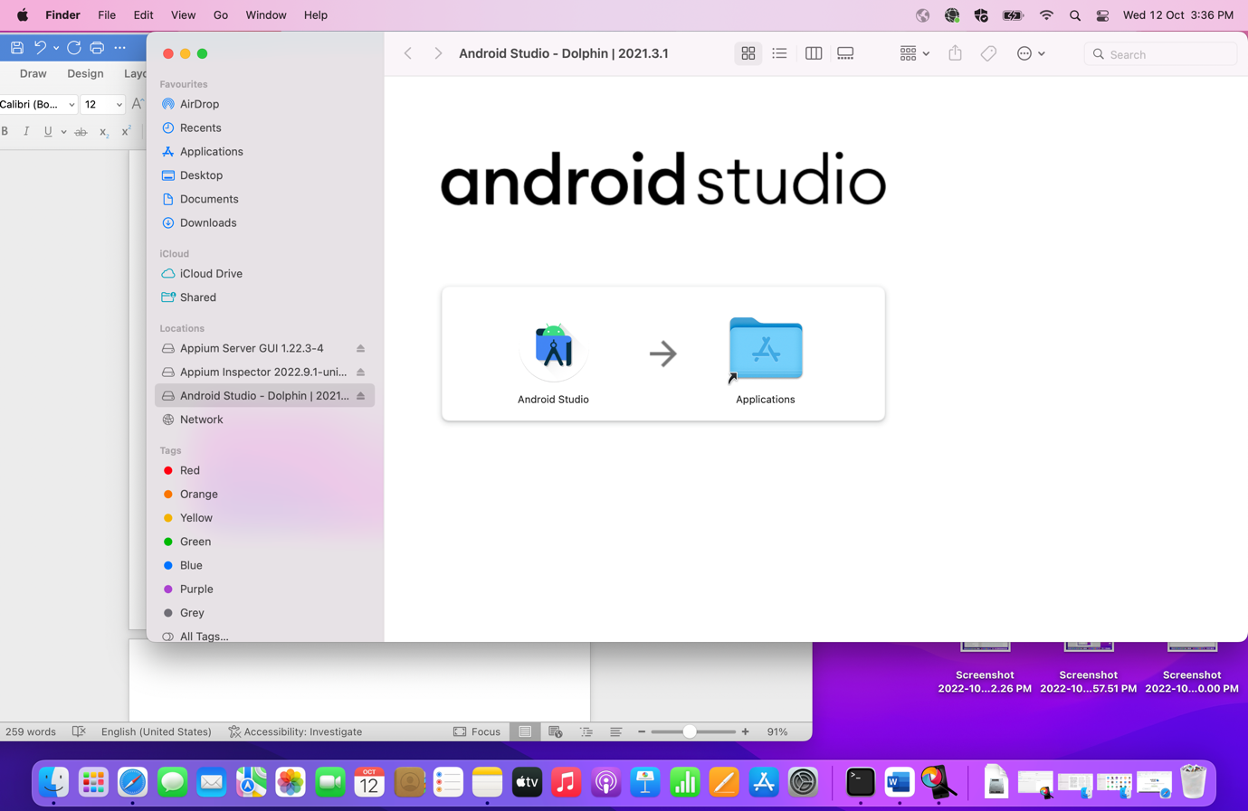

🡪Check Android Studio is now displayed in Application folder or not.

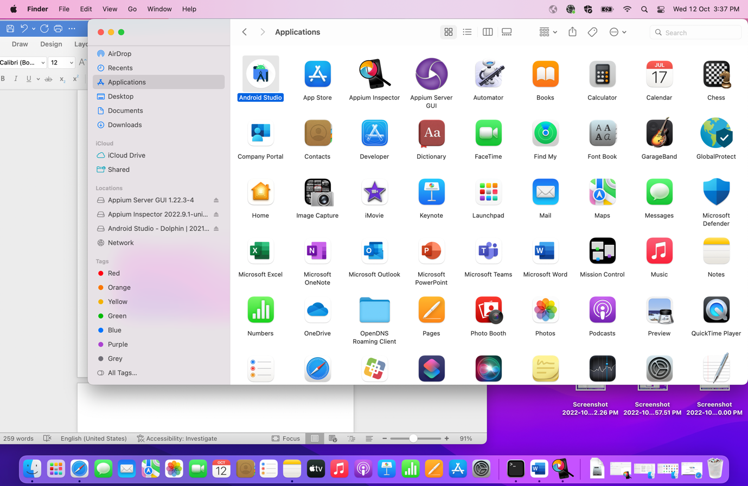

🡪Open the Studio and click on next until you reach to Finish button. Accept the terms and conditions and click on Finish

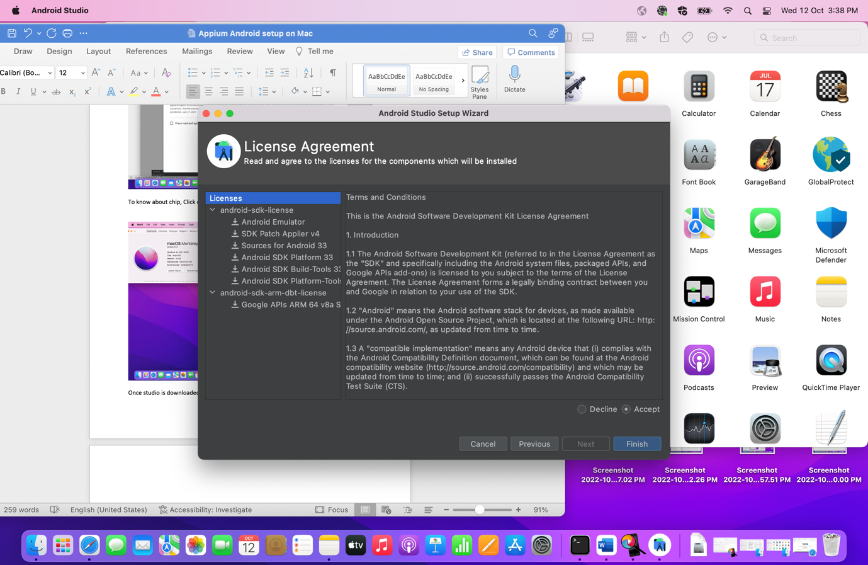

🡪Wait for some time and let it download all the packages

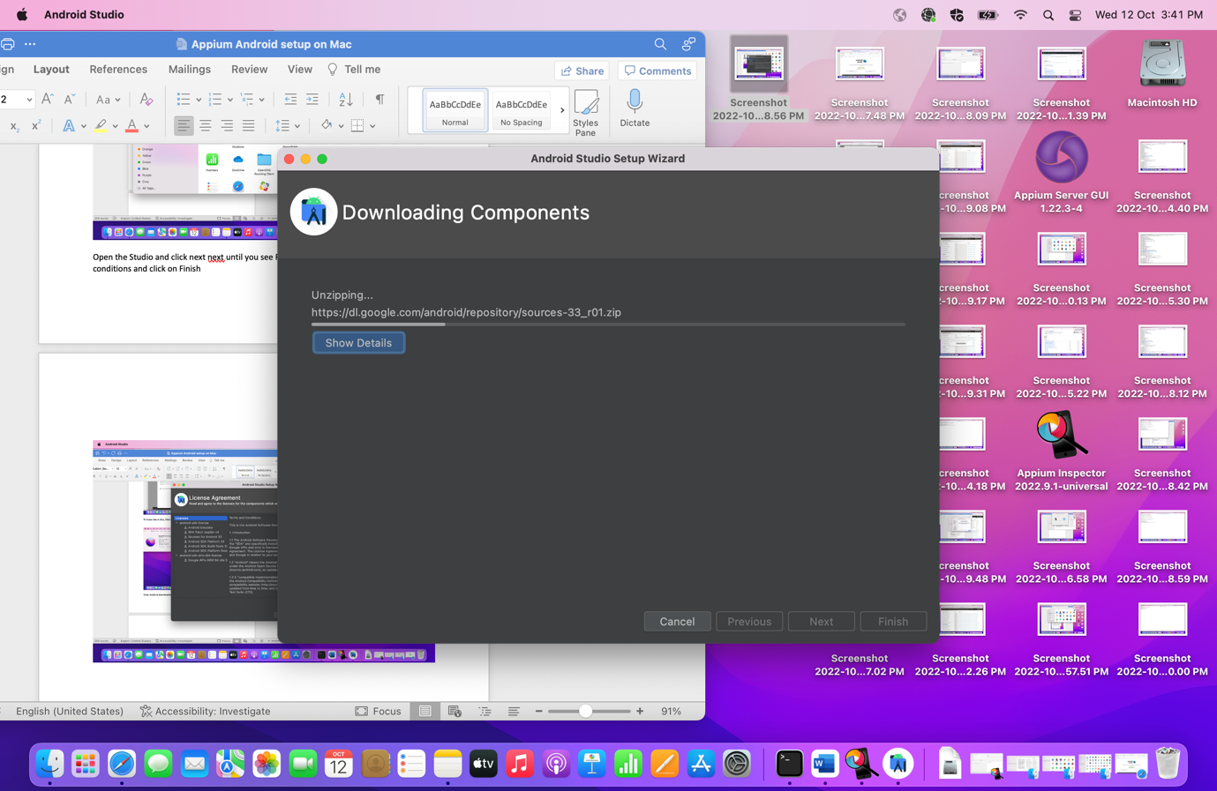

🡪Click on Finish button

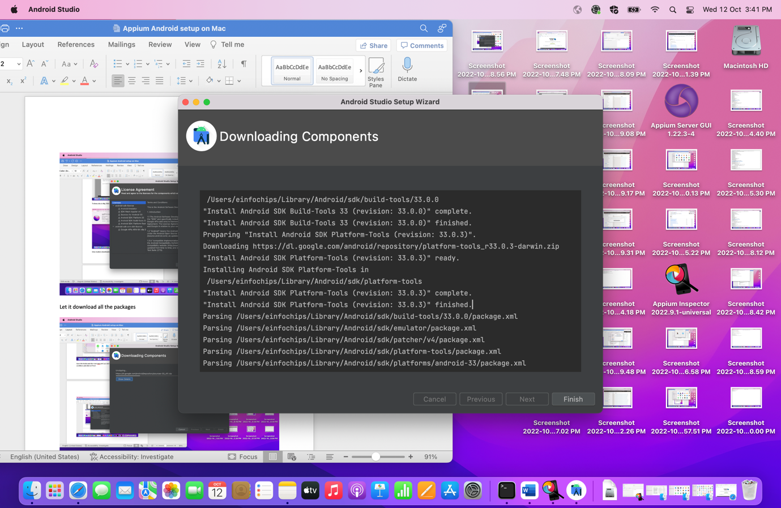

🡪Click on New Project. It will take some time to download dependencies.

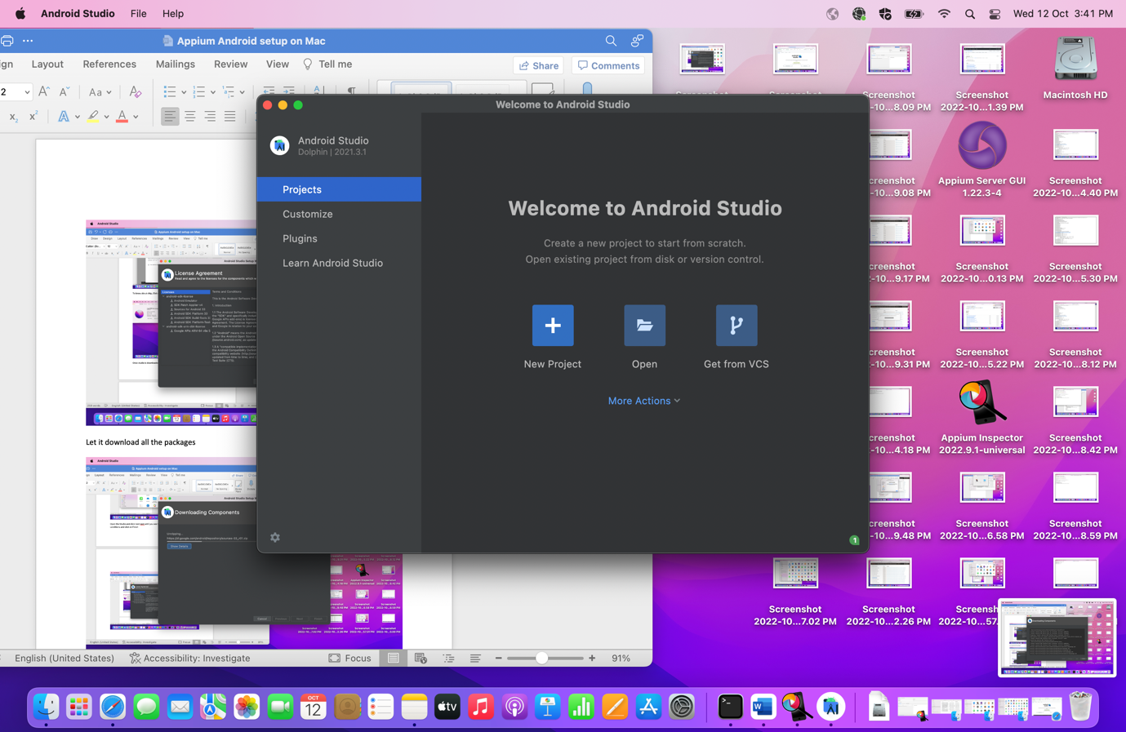

🡪Click on SDK Manager as given in below screenshot

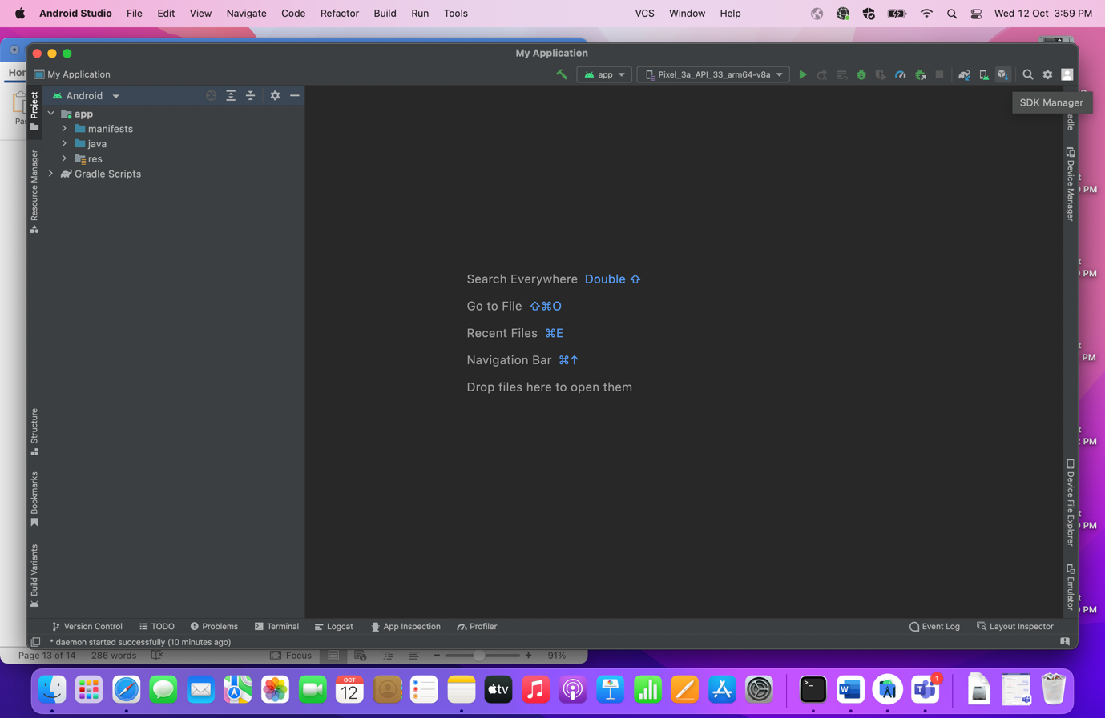

🡪Click on Android SDK

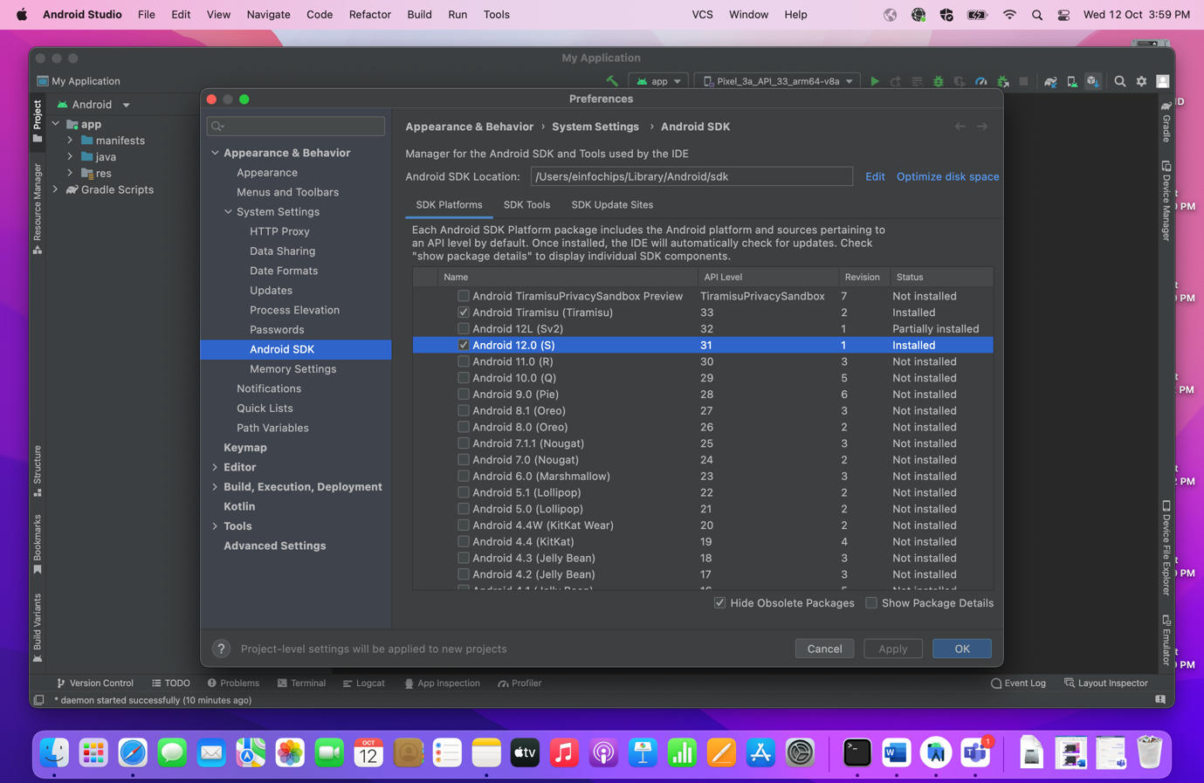

* Select the Show Package details checkbox on right bottom side to check the package details

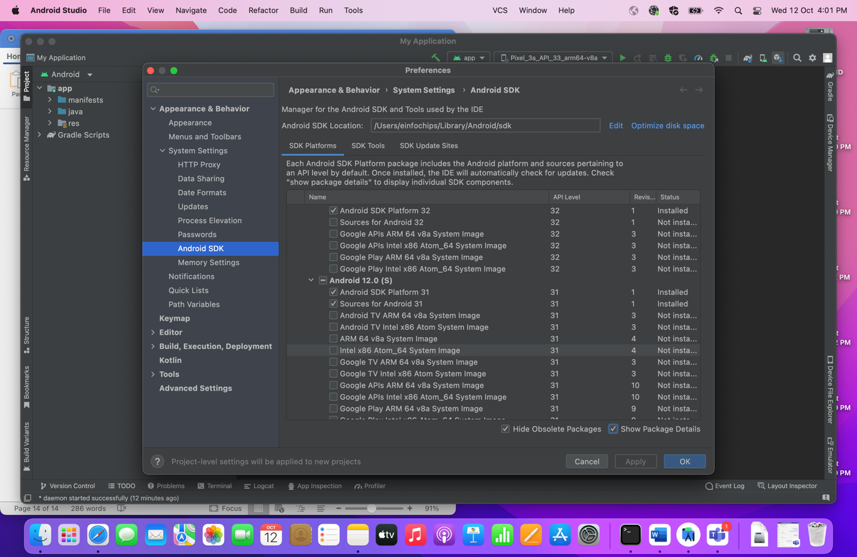

🡪Go to SDK Tools tab and verify the Android Emulator is installed. When you check the other checkbox, you will get download button where you can download other tools as per requirements.

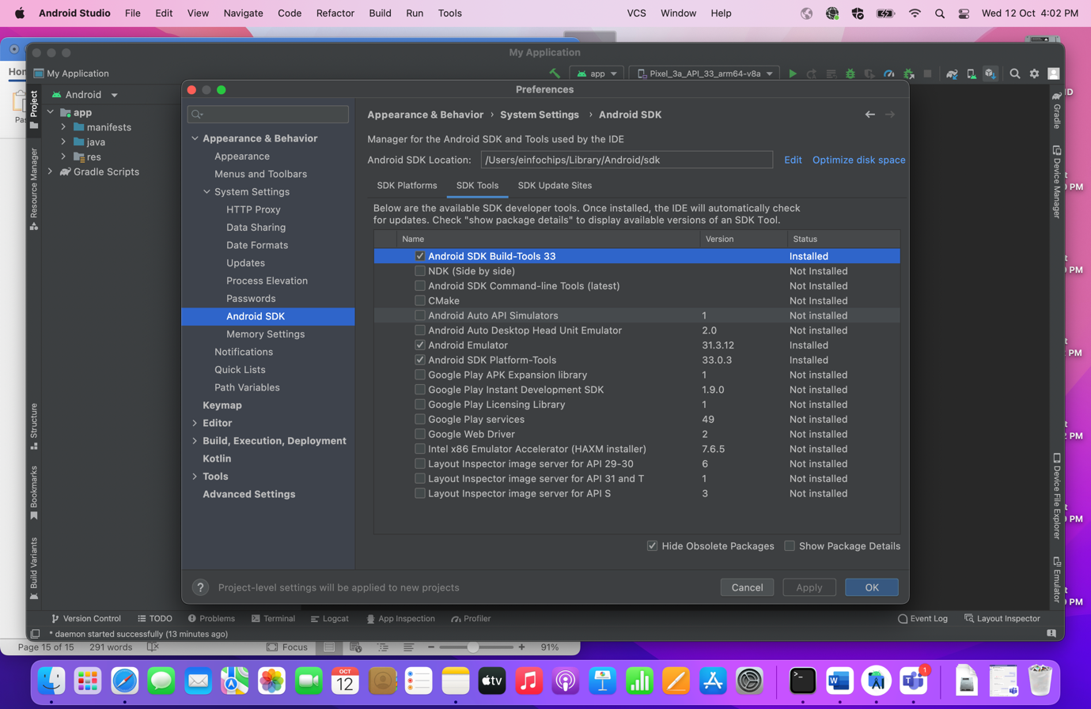

🡪Install Android Command Line tools and Android SDK Build Tools.

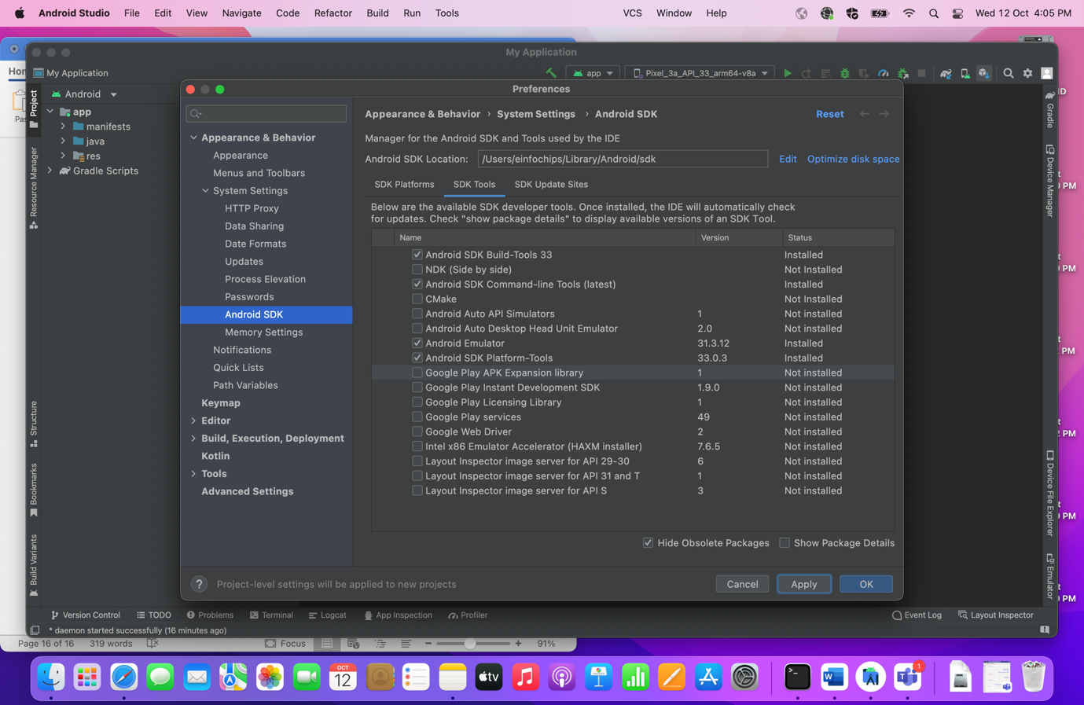

🡪Intel x86 Emulator Accelerator (HAXM installer) is used when we are working for virtual devices so to boost the system performance we can download and install it. (for Intell Processor only, it is required—Just for reference)

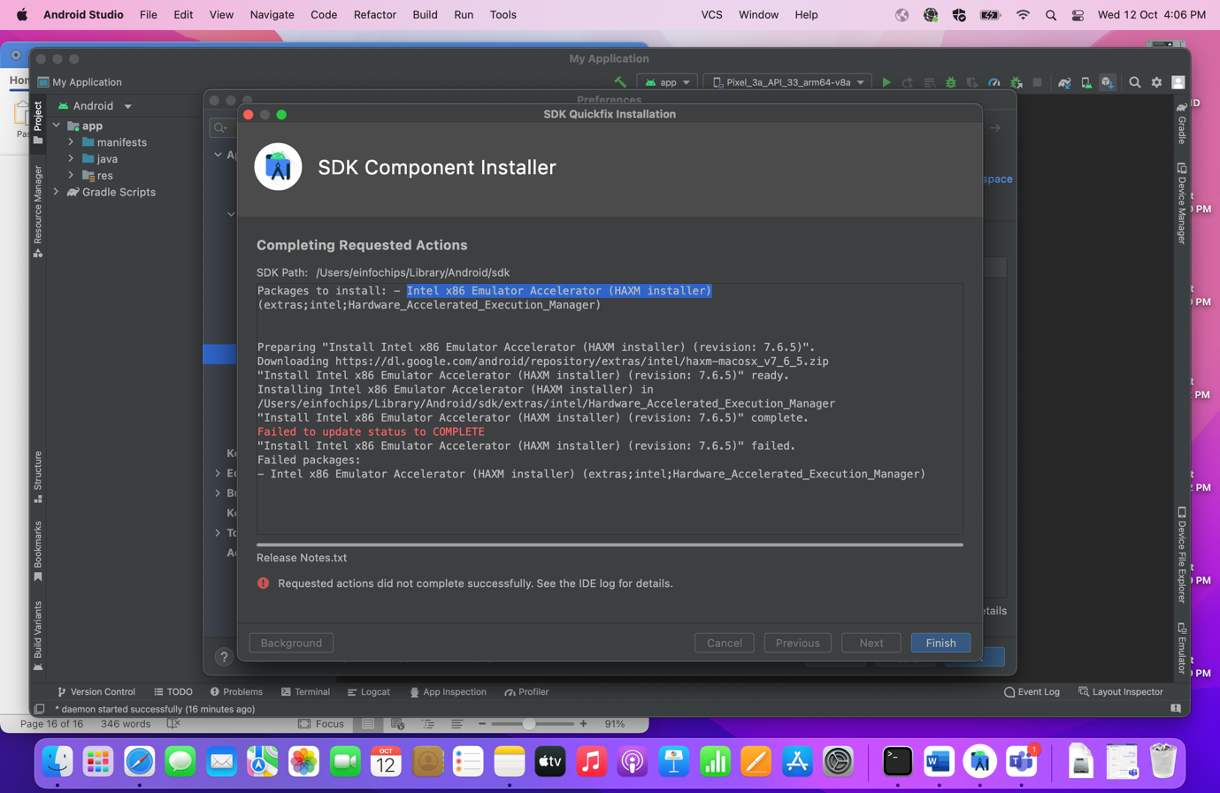

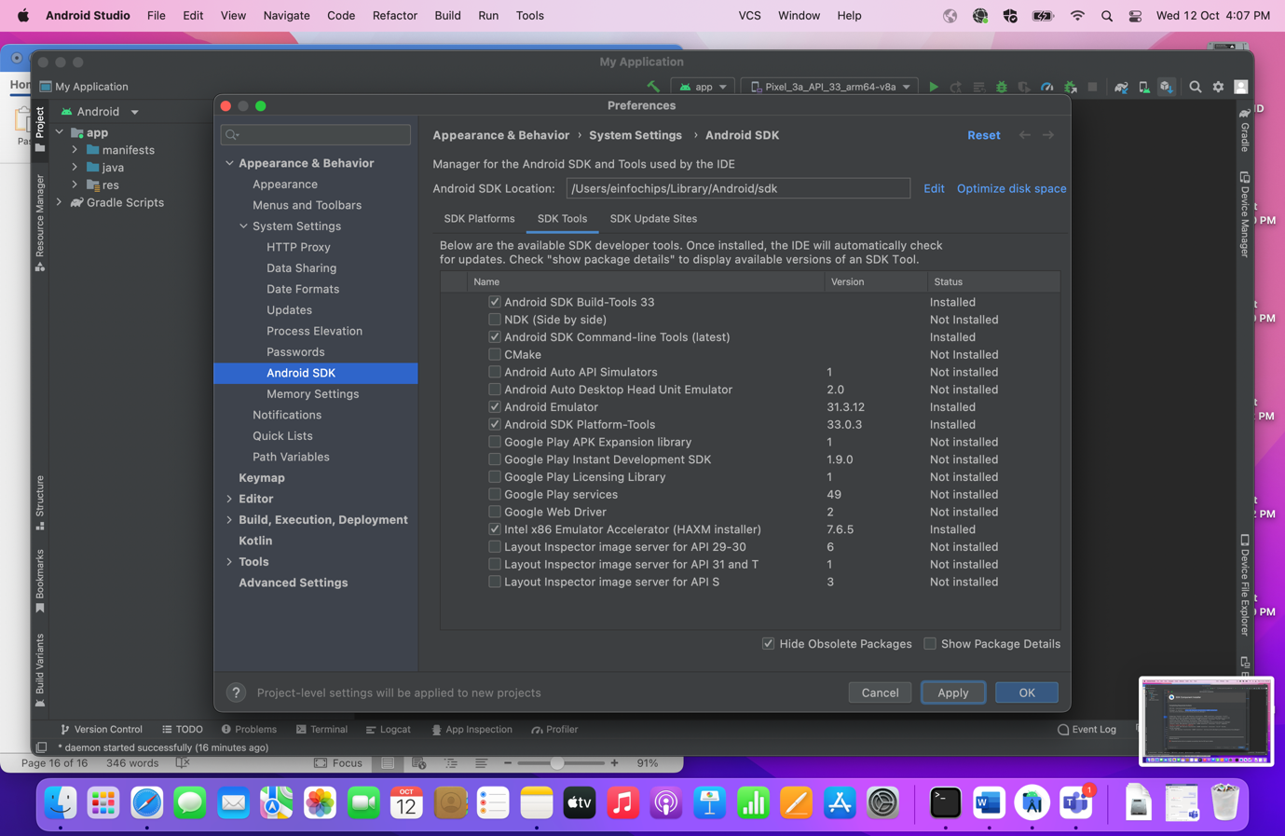

**Step 8: Install Appium doctor through the terminal by executing below command. (Appium Doctor is to diagnose and fix common Node, iOS and Android configuration issues before starting Appium.)**

**🡪Run this:**

npm install -g appium-doctor

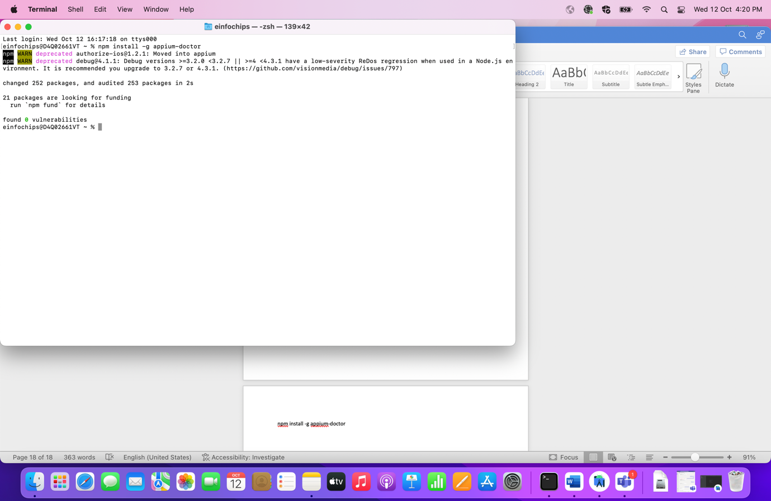

🡪We can check android setup

**🡪Run this:**

appium-doctor --android

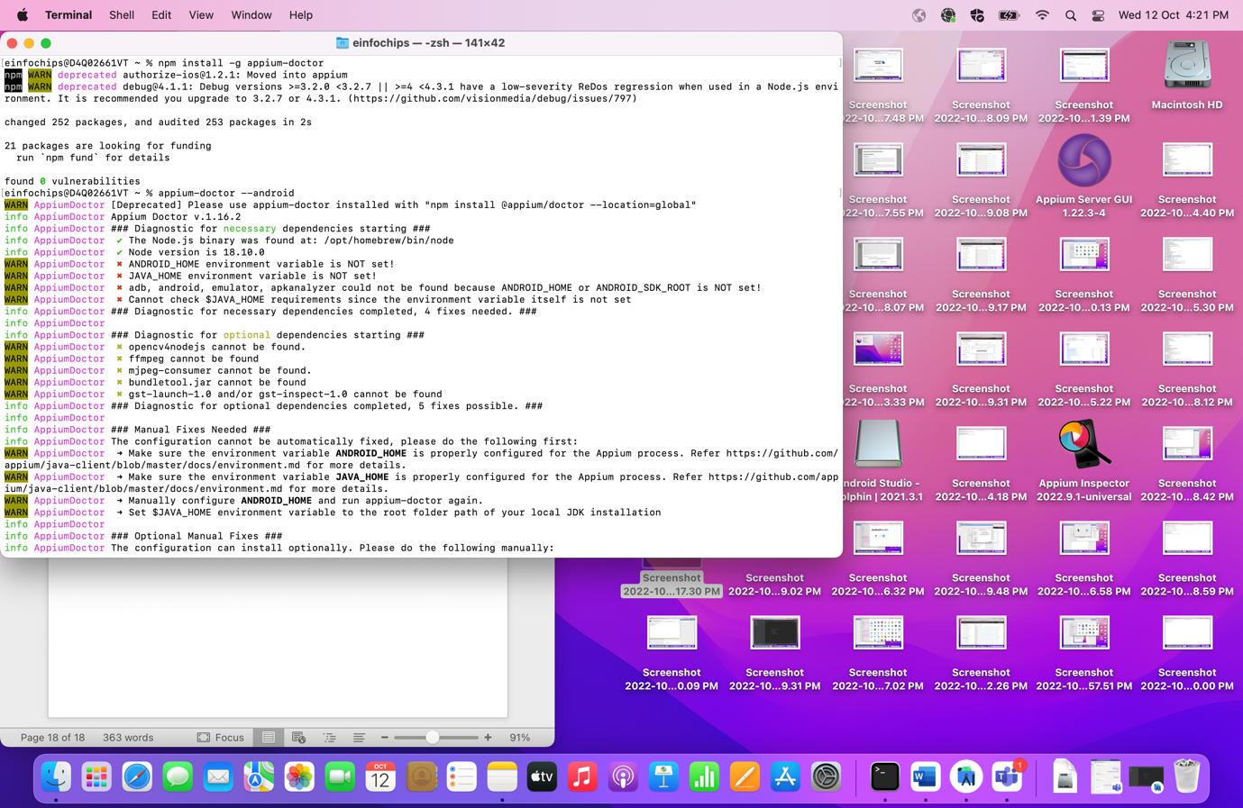

🡪We can see Java, Android and some other relevant details.

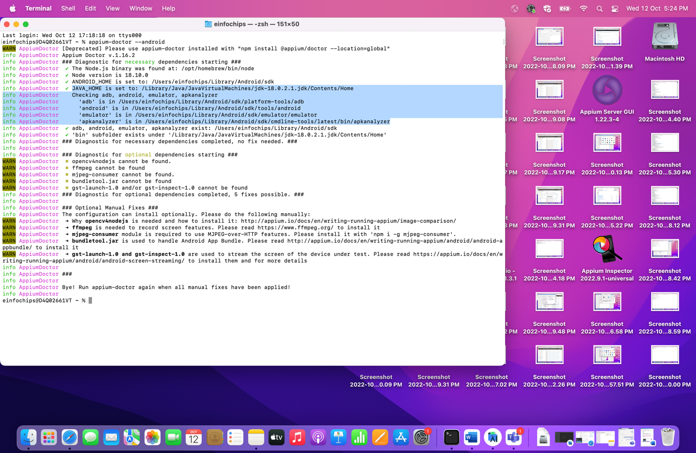

**Step 9: Set System Variable for Java and Android home**

🡪Open Terminal and run the below commands

1. cd ~/
2. touch .zprofile
3. open -e .zprofile

🡪So above three commands will navigate to home directory, then it will create and open zprofile where you can set system variable.

🡪set the below path in your zprofile box

export JAVA_HOME=/Library/Java/JavaVirtualMachines/jdk-18.0.2.1.jdk/Contents/Home

export ANDROID_HOME=${HOME}/Library/Android/sdk

export PATH="${JAVA_HOME}/bin:${ANDROID_HOME}/platform-tool:${PATH}"

🡪Once path is set, verify with below commands (Close your terminal and then after check by opening new Terminal otherwise it will display nothing)

**🡪Run these:**

echo $PATH

echo $JAVA_HOME

echo $ANDROID_HOME

This will give you the system variable contents.

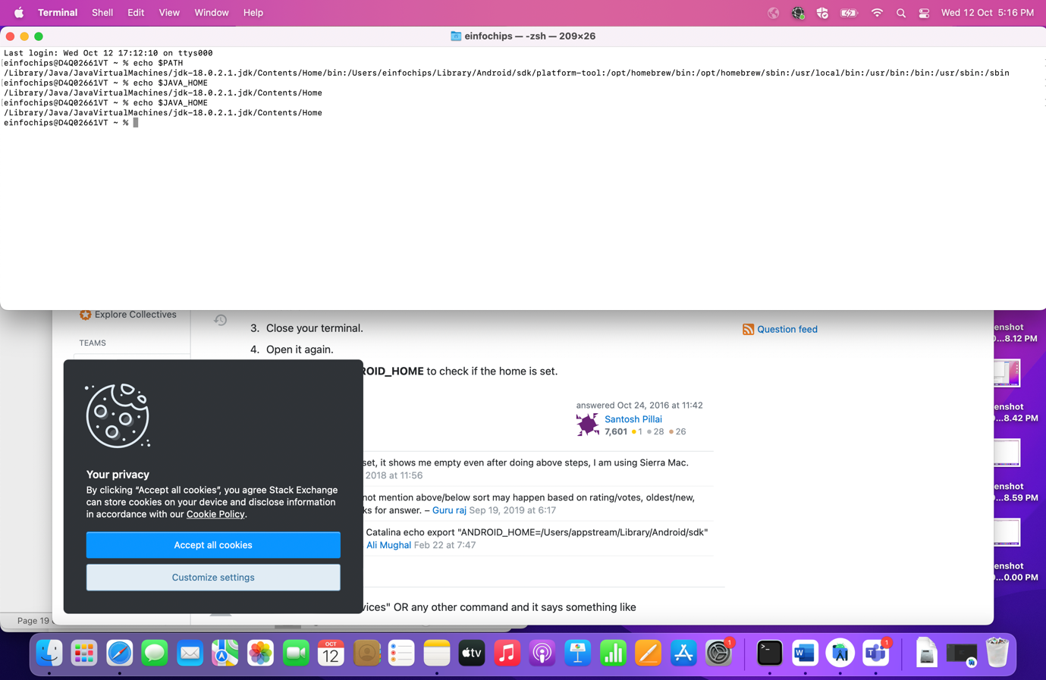

Step 10: Verify that your Appium Studio, Server and Inspector is working properly manually

🡪To check the connection between all above tools, follow the below steps.

🡪Scenario: Open Android Studio and create new device, connect with Inspector for same device and at last log the activities on Server.

🡪Click on Create Device on Android Studio

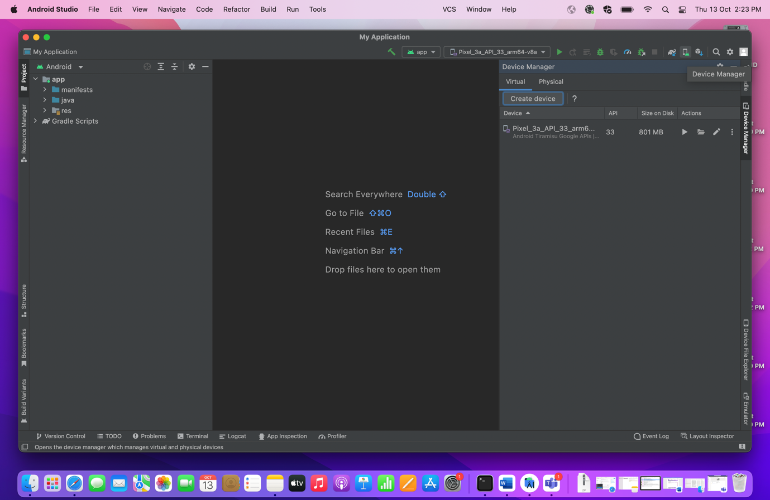

🡪Select Phone as per your requirements. (I am selecting Pixel 4 here with android 11)

🡪Follow the steps as shown in screenshots till you get your emulator in devices.

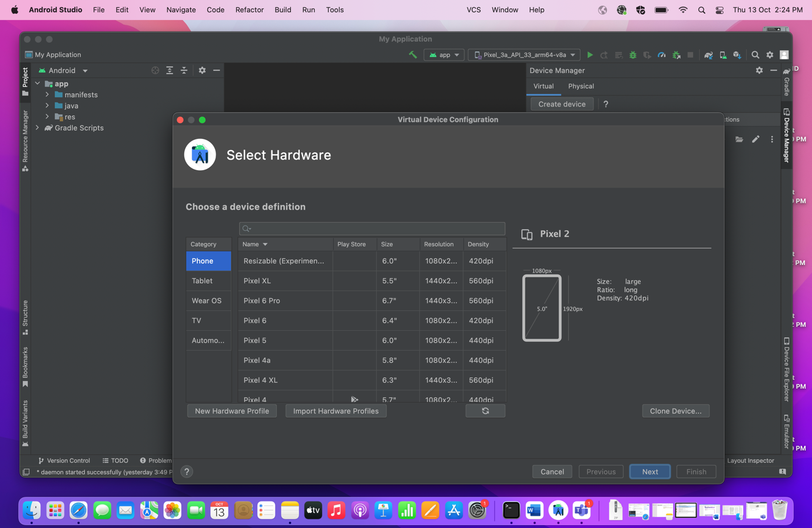

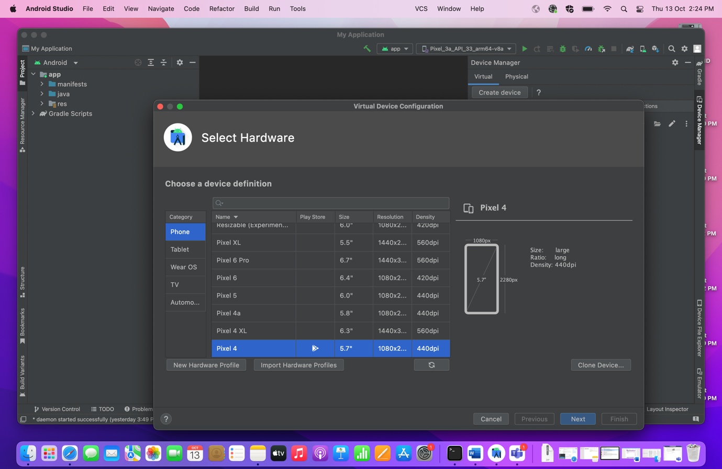

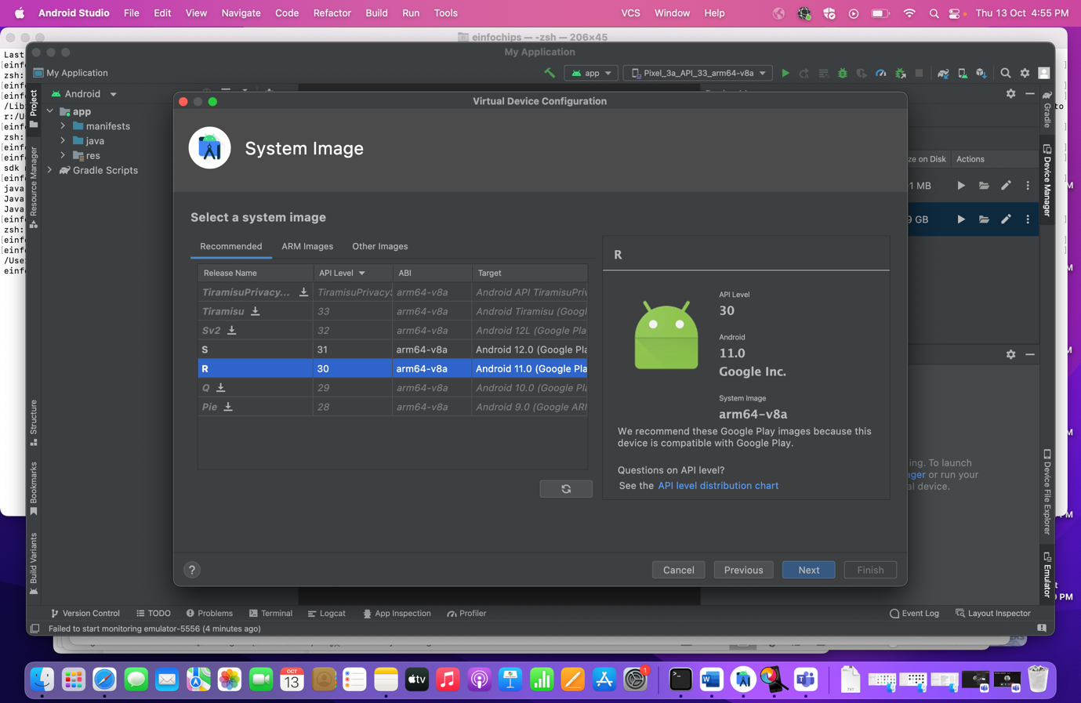

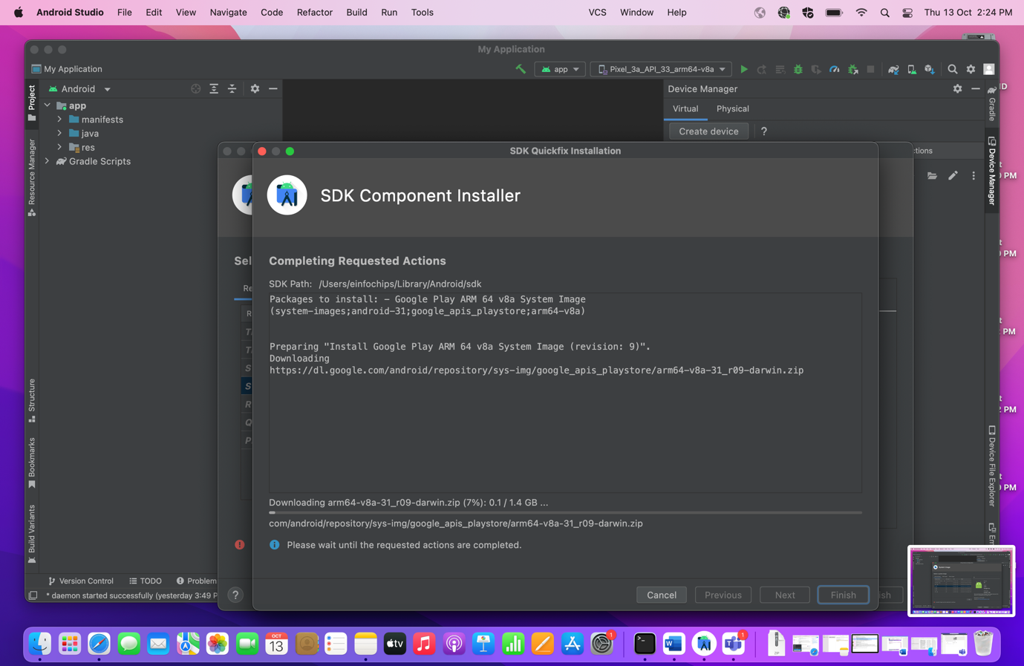

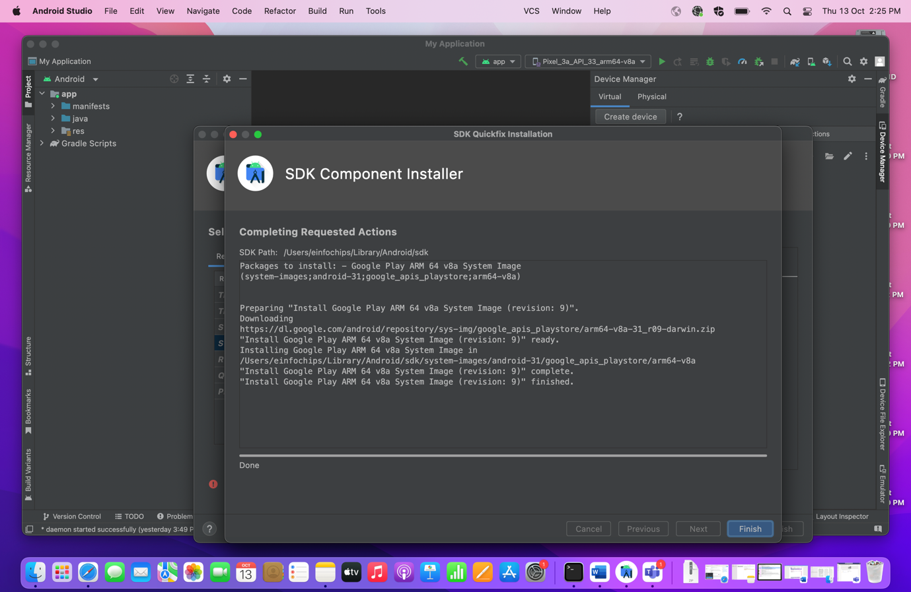

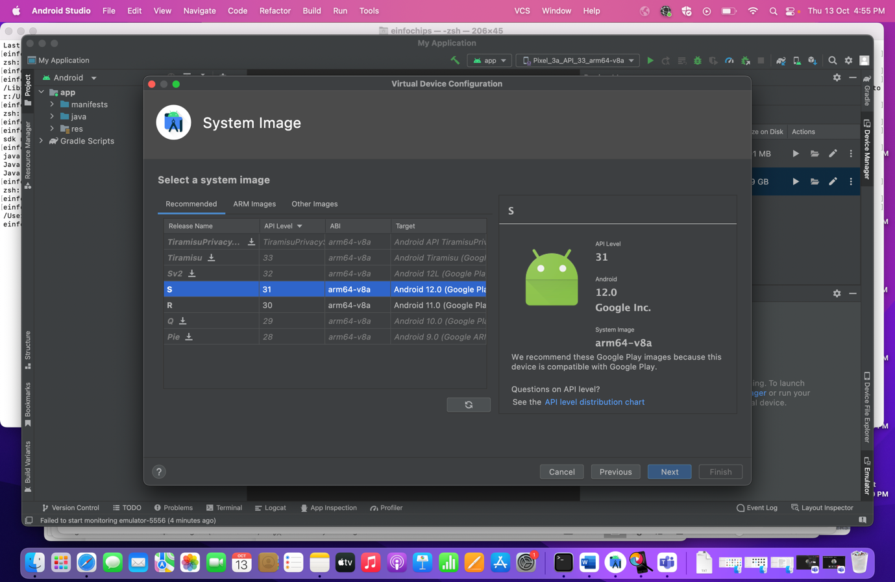

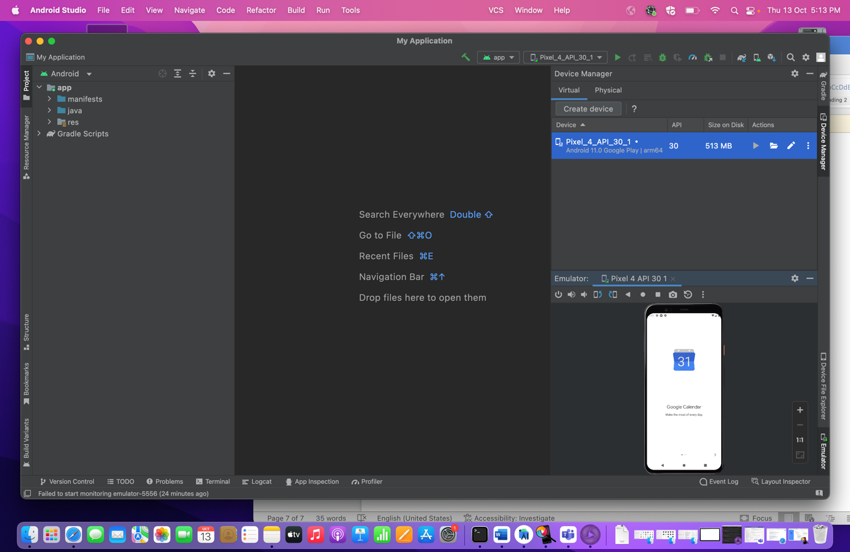

🡪Emulator is ready now. Lets start server with below host and port values

**Host: 127.0.0.1**

**Port:4723**

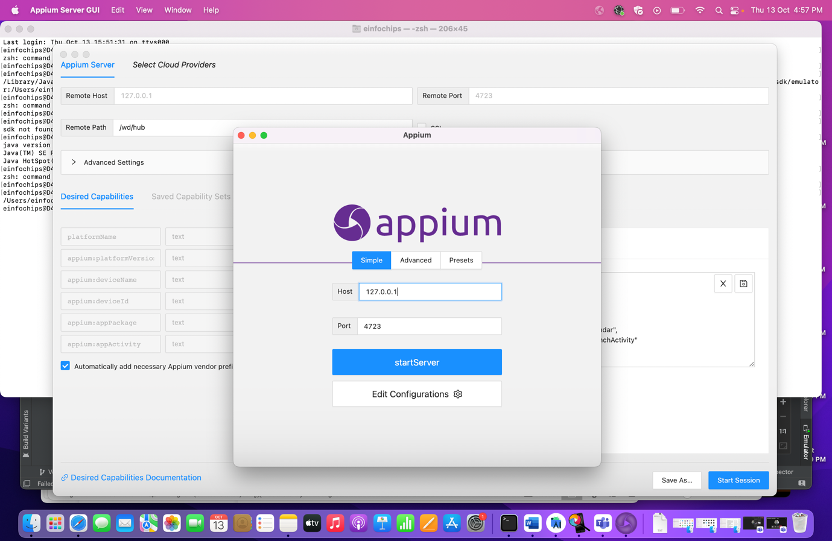

🡪Now Open Android Inspector and give below capabilities to start inspect mobile elements.

{

"platformName": "Android",

"appium:platformVersion": "11",

"appium:deviceName": "Pixel_4_API_30_1",

"appium:deviceId": "emulator-5554",

"appium:appPackage": "com.google.android.calendar",

"appium:appActivity": "com.android.calendar.LaunchActivity"

}

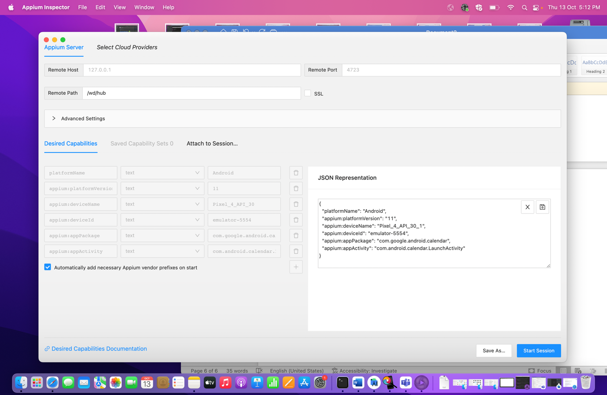

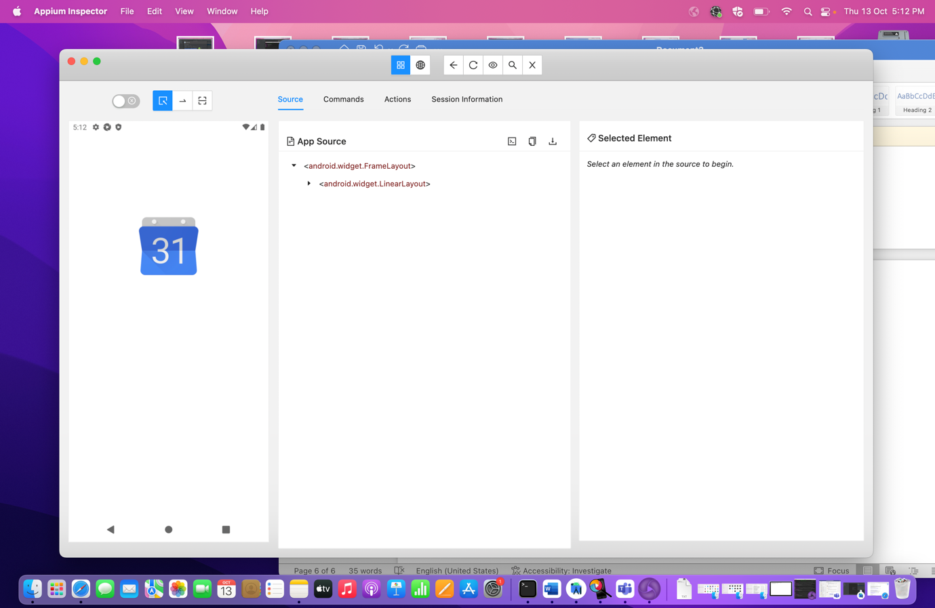

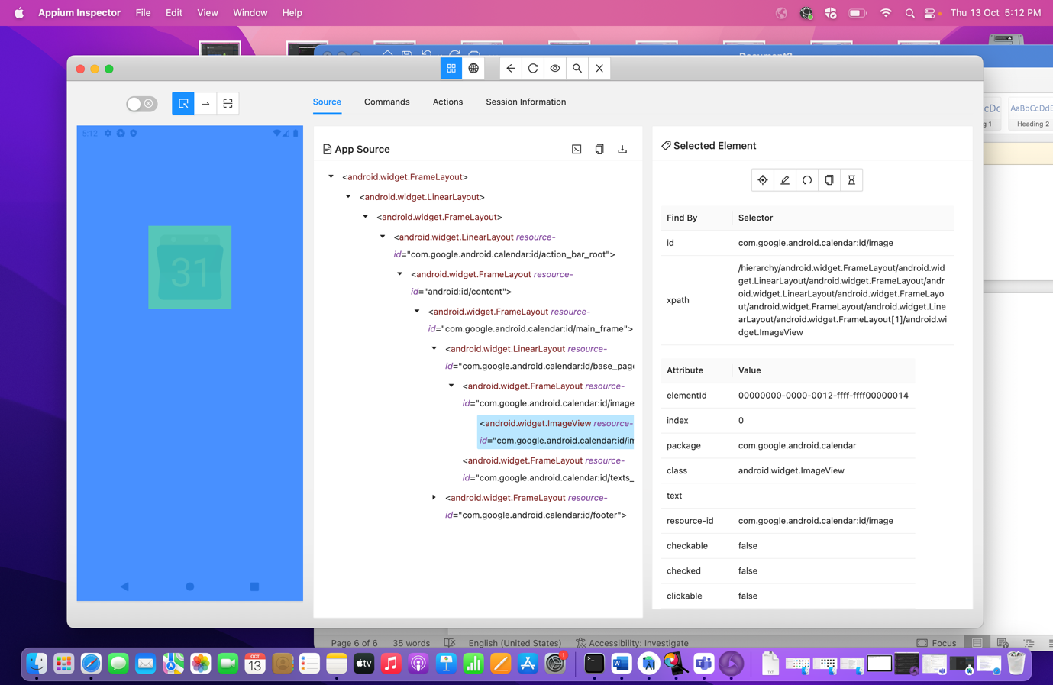

This way we connect with different types of emulators.

Note: Select your emulator by creating device on Android studio only.

---------------------Finish---------------------